WEEK 4 : INFORMATION GATHERING AND RECONNAISANCE

Fig 1: Identifying the company domain name
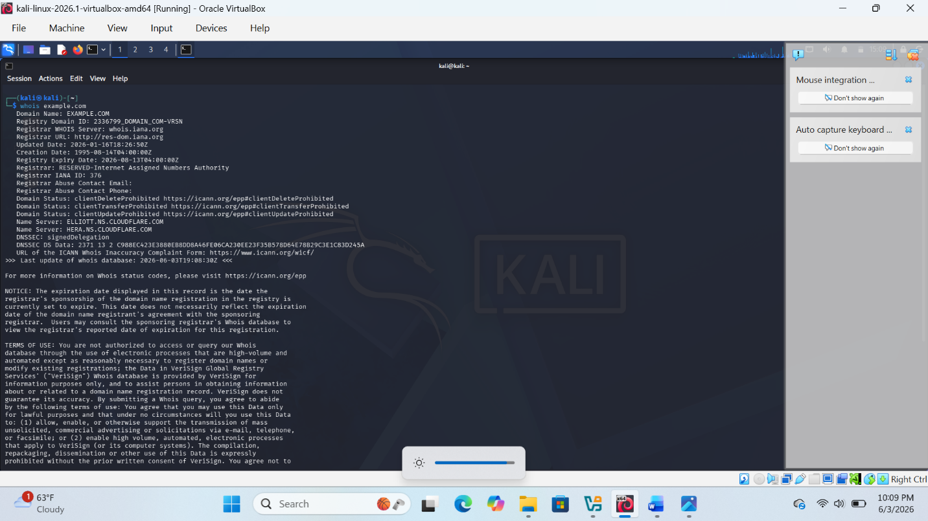
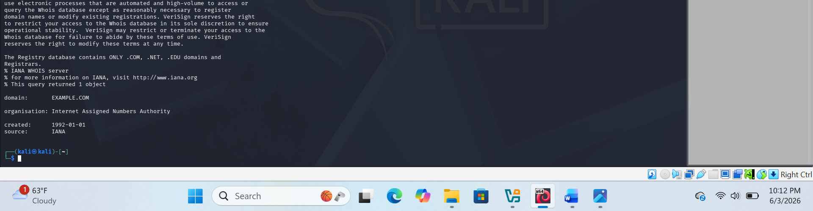

Fig:2 Identifying Open ports services
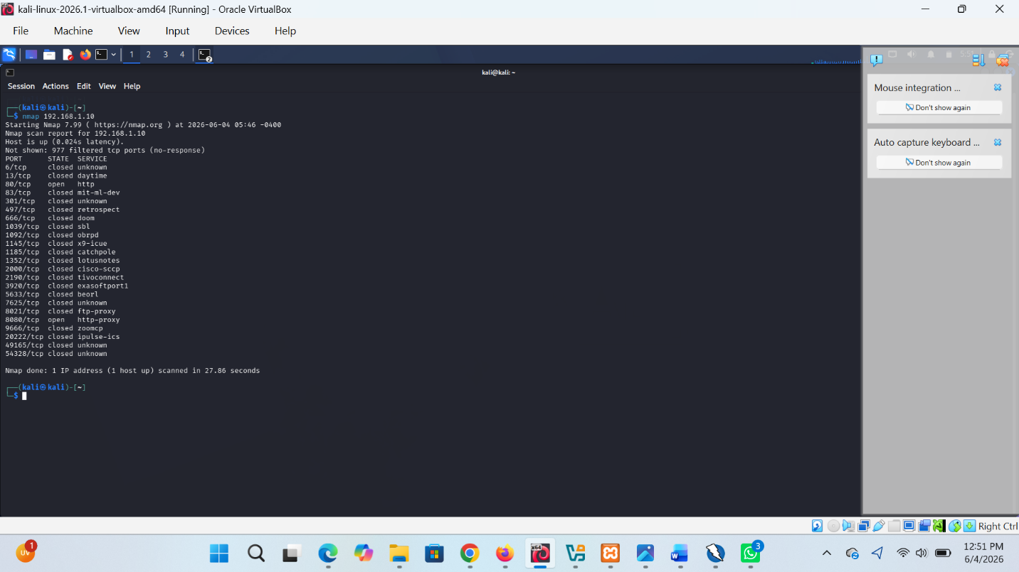

Fig 3: Detect running services
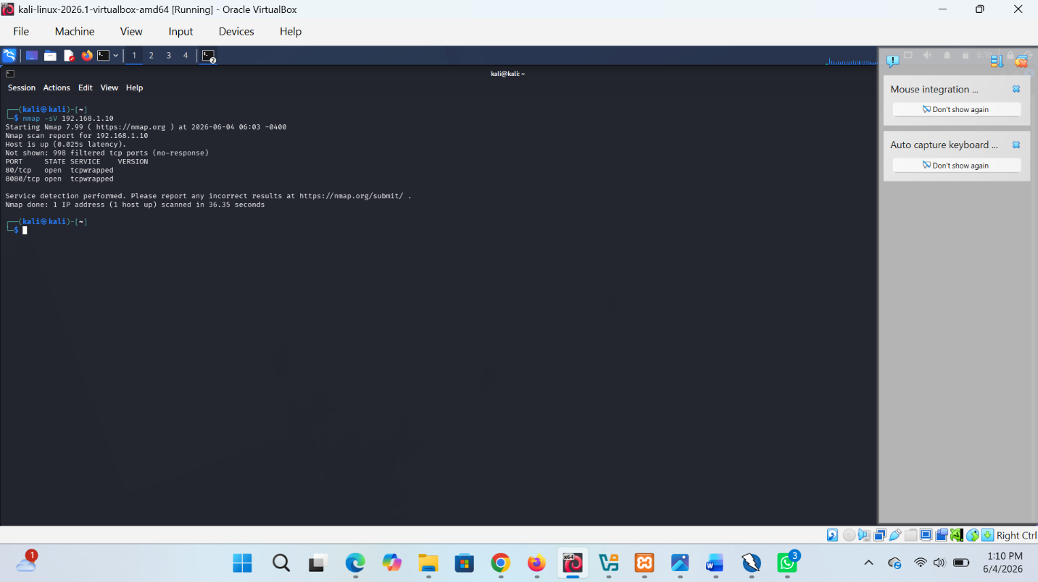

Fig 4: Identify the Sub domains
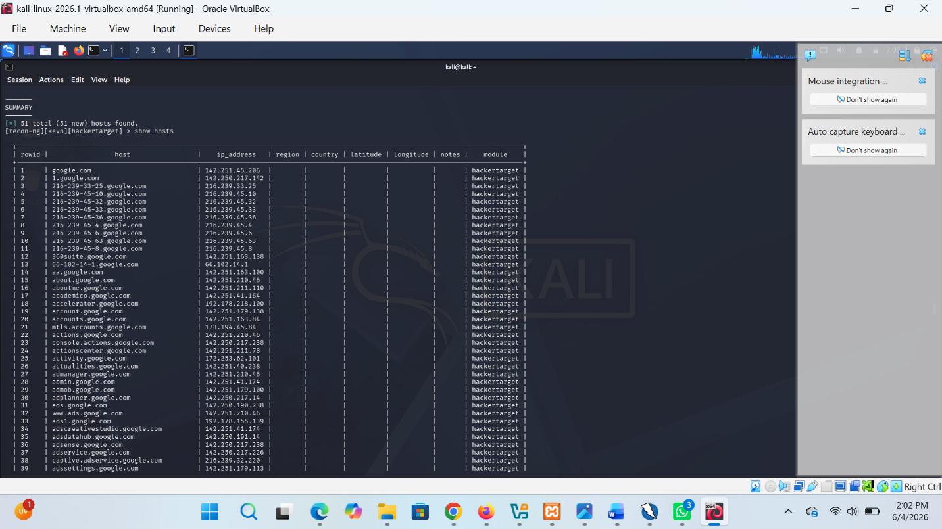

Fig 5: List shared Folders
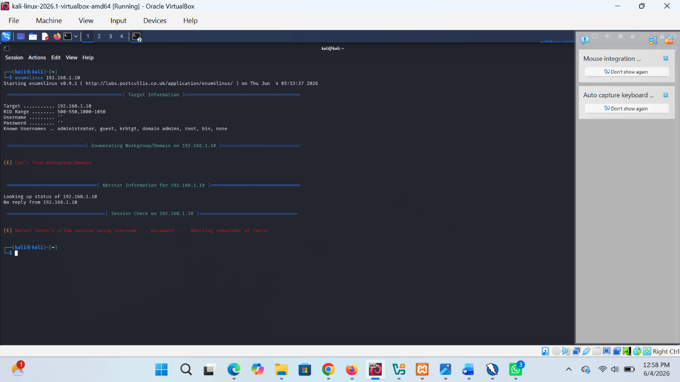

Fig 7:Credential details of the members of the
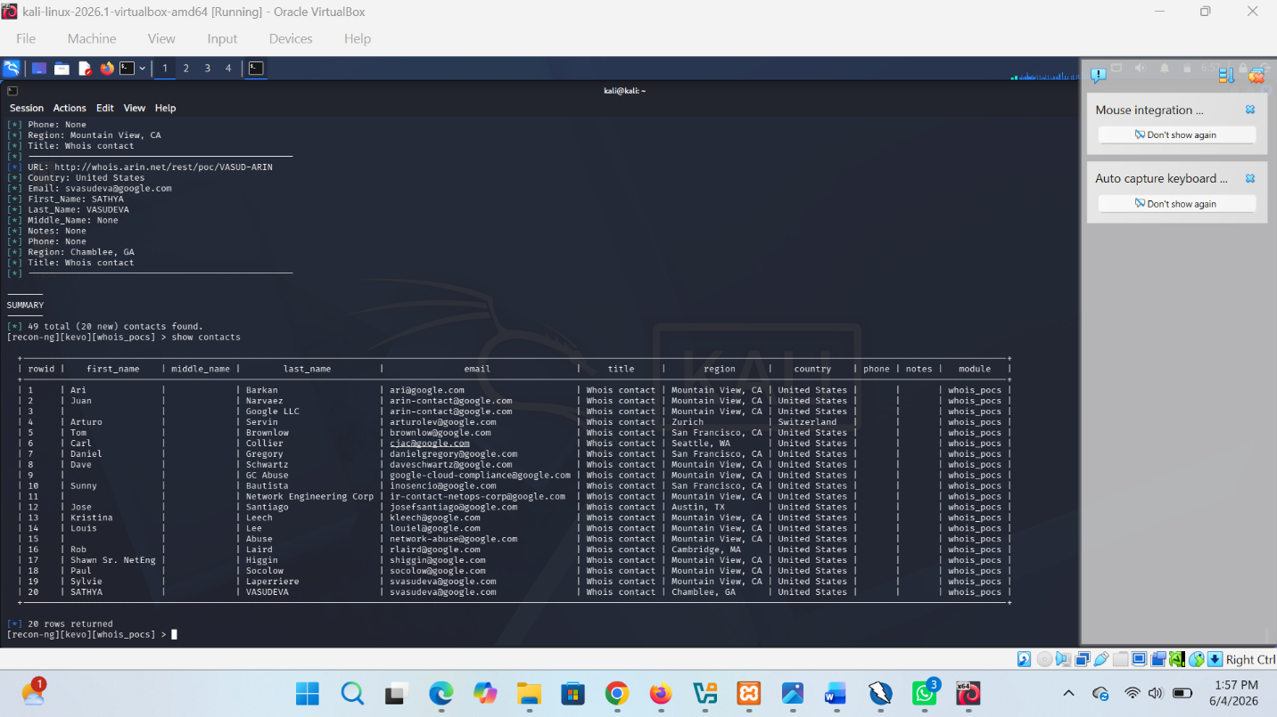

Week 4 REFLECTION:
Student Reflection
This lab helped me understand the basics of scanning and enumeration using Kali Linux tools. I learned how to identify open ports, detect running services, and check for shared resources on a network. I also gatroubleshooting connectivity issues and interpreting scan results. The exercise improved my practical cybersecurity skills and showed the importance of securing exposed services and network resources.

